**EMPLOYEES’ DATA**

Please add Picture for every employee

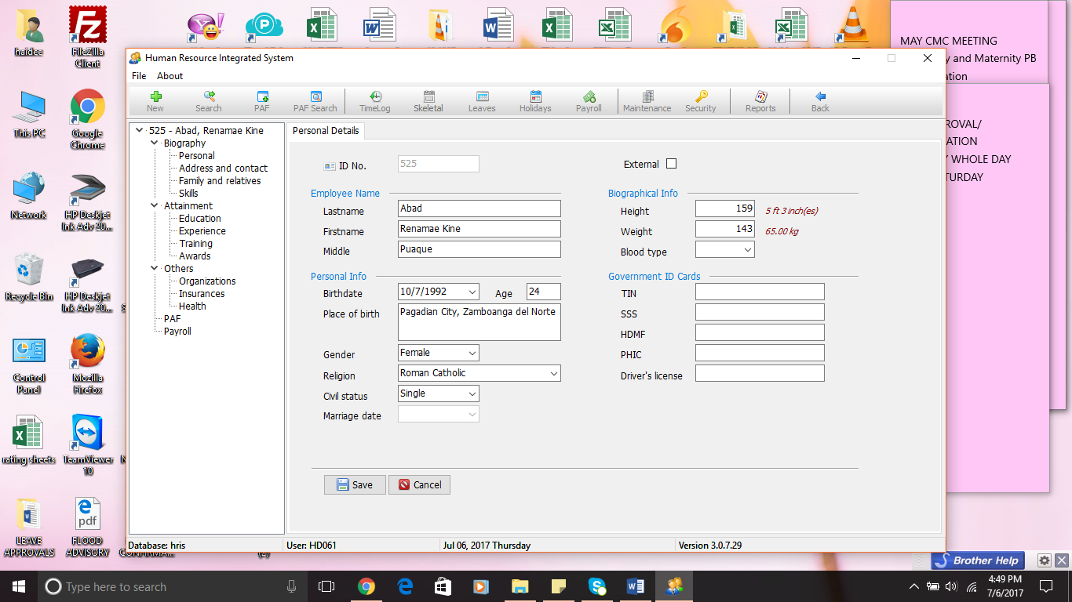

Suggested

Biography

* + Personal ( with picture and specimen signature )
* Address and Contact ( House sketch )
* Family and Relatives ( Dependent ; ASCC Beneficiary ; Vita Cura Beneficiary)
* Health / Medical
* Skills
* Interest/ Hobbies

Attainment

* Education
* Organizations
* Licenses
* Awards ( school and community)

ASCC Employment Data

* Performance Records
* Disciplinary Records
* Company Awards and Recognition
* Special Employment Conditions

Separation

* Resignation Date
* Reasons for Resignation
* Exit Interview Notes

**SKILLS/ INTERESTS AND HOBBIES**

Special Skills _________________________

_________________________

Driving yes no

Interests /HOBBIES

_________________________

_________________________

_________________________

EDUCATION

School Address Year Graduated

Primary ____________________ ______________________ _________

Secondary ( JHS) ____________________ ______________________ _________

Secondary ( SHS) **( provide list of schools)** ______________________ _________

College ____________________ ______________________ _________

Course ____________________

Others ____________________ ______________________ _________

**Note: we will be needing data / report on list of employee who graduated from a particular school**

**: We will also be needing a report that will show employees’ who graduated with a specific course**

**Previous Work / Business Experiences**

Position Company Address Period

OJT ____________ _______________ _____________________ ___________

Part-time Jobs ____________________________ _____________________ ___________

Full time work ____________________________ _____________________ ___________

Business Engagement ____________________________ _____________________ ___________

**Training Record**

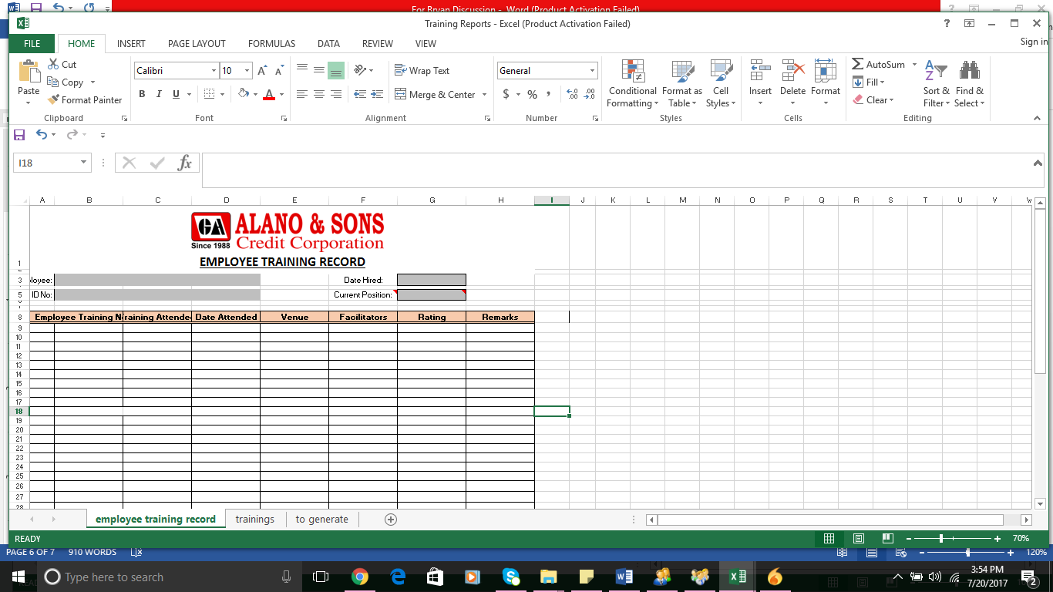

**Awards and Recognition in ASCC**

Awards Date Awarded

* Perfect Attendance ( quarterly )
* Perfect Attendance ( Annual )
* Most Outstanding Employee
* Most Outstanding BM
* Commendations
* 6s Awardee
* Extra S-mile Award
* Loyalty Award
* Others------

Report to be generated from this:

1. Awards received per employee with corresponding dates
2. Recipient of Every Awards – can be shown per employee or according to date of award

**Organizations**

Name of Organization Position Date of Membership

**Insurances**

**Type Insurance Company Face Amount Policy Number Beneficiary**

Health

Life

Accident

Funeral

Others ….

**Health Records**

**Allergies**

**Continuing / Existing Medical Conditions**

**Medical Condition Medication Physician Doctor’s No. Preferred Hosp**

1. Hypertension Drug A Doc AAA 0967676786786 OKD
2. Heart Problems

**Annual Laboratory Tests Results**

**Date Tests Results ( higher or lower than range) Doctor’s Advise**

**Medical records**

**Date Diagnosis Treatment / Prescribed test/ meds Doctor**

**Food preferences:**

* **Beef, pork, etc**

**Summary of Movements/ Personnel Action**

**Date Position Branch Status Salary Allowance Remarks**

Example

6/1/17 BM Main Office Acting 10,000.00 Rep- 1,000.00 For confirmation after 6 months

12/1/17 BM Main Office Confirmed 15,000 Rep-1,000.00

03/15/18 BM Bogo Branch Confirmed 15000 Rep-1000.00 Applied for personal reasons ( not MIT)

Lodging-1000

Relocation 1000

|  |  |
| --- | --- |
|  | |
| PREVIOUS ASSIGNMENT | | | NEW ASSIGNMENT | | Date of | Remarks |
| Branch | Position | | Branch | Position | Effectivity |
| Buug | Account Officer | | Resignation | | 4-Feb-17 |  |

**Payroll Summary**

Payroll Period Monthly Basic Half Month Basic Gross Salary Net Pay

May 21-June 5 10,000 5000 4500 3000

June 6-June 20 10,000 5000 4800 4000

**Disciplinary Records**

|  |  |  |  |  |  |  |  |  |
| --- | --- | --- | --- | --- | --- | --- | --- | --- |
| Incident Report/Source | VIOLATION (Section & Article base on the Rules & Regulations) | Description of the Incident | Notice to Explain | | Explanation Received | Schedule of Admin Hearing | Notice of Decision | |
| Date of NTE Issued | NTE Issued by | Date of Decision | Verdict | Sanction |
|  |  |  |  |  |  |  |  |  |  |
|  |  |  |  |  |  |  |  |  |  |

**Leave Credits**

Vacation Leave Credits **7** **Balance 0**

Date of Availment No of Days Reasons

*Jan 2-5 5 days Family Vacation*

*March 2-3 2 days* *Attend Wedding*

**Total: 7 days**

**IMPROVEMENT OF EXISTING MODULES**

LEAVE MODULE : To show leave balances

PAF MODULE : Add choices ( for Promotion and transfer allowance ? yes or no. if Yes, applicable quarters ) – report can be generated who will be entitled with promotion and transfer allowance per quarter.

To include details of other allowances not included in payroll ( will not be computed for payroll purpose:

Cost of Living allowance –with expiry

( One time relocation ; promotion and transfer ; Special Allowances;

**REPORTS**

**TRAINING**

|  |
| --- |
| * Trainings conducted at any given period (as presented) |
| * List of employees that have undergone one program |
| * Employees required to undergo one training program |

**EMPLOYEE RELATIONS**

* List of Awardees – MOE, MOBM, Perfect Attendance , Loyalty, others ( for a given period )

**ACCIDENT REPORT**

**DISCIPLINARY RECORD**

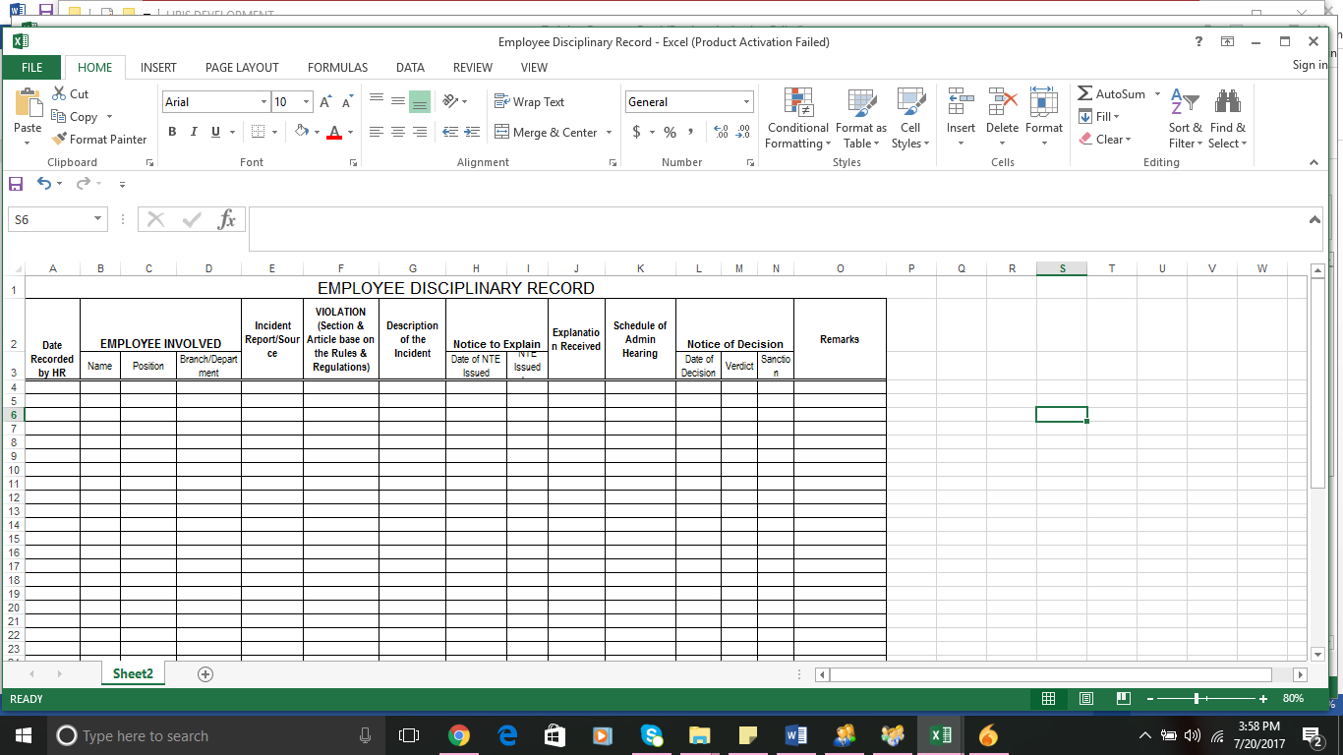

**PERFORMANCE MANAGEMENT**

* Performance Appraisal ratings ( per period ) – for 5 years

Name of Employee Position Part 1 Part II Average Strengths Areas for Improvement Training Needs

**RECRUITMENT**

* Recruitment Record

|  |  |  |  |  |  |  |  |  |  |  |  |  |  |  |  |  |  |  |  |
| --- | --- | --- | --- | --- | --- | --- | --- | --- | --- | --- | --- | --- | --- | --- | --- | --- | --- | --- | --- |
| **Date of Examination** | **Venue of Examination** | **Recruitment Channel** | **Referral's Name** | **Relationship with Referral** | **NAME OF APPLICANT** | **Course** | **HOME ADDRESS** | **AGE** | **GENDER** | **CELLPHONE NUMBER** | **IQ score** | **Preliminary Interview** | | | **Final Interview** | | | **Background Investigation Result** | **REMARKS** |
| **Date** | **Interviewer/s** | **Result** | **Date** | **final Interviewer/s** | **Result** |
| 6/30/2017 | Dipolog City | Internet-FB | Jose Basal | Friend | Acalain, Christian S. | Computer Science | Miputak Dipolog City | 21 | M | 0997-710-4574 | 60% | 7/4/2017 | Jessa Gudmalin | pass | 7/5/2017 | Haidee & Ma. Nova | pass | pass | Decline |

* **List of Employees** with options to show based on date hired, regularization date, length of service, age, gender, civil status , birthdays, course graduated, branch, Area, Salaries, Allowances, others
* Regularization Date ( prompt/ monitor )
* Confirmation Date ( monitor )
* Monitoring of COLA increases ( expiry dates on PAF? )

Employee HeadCount Report (per area, per branch, over-all)

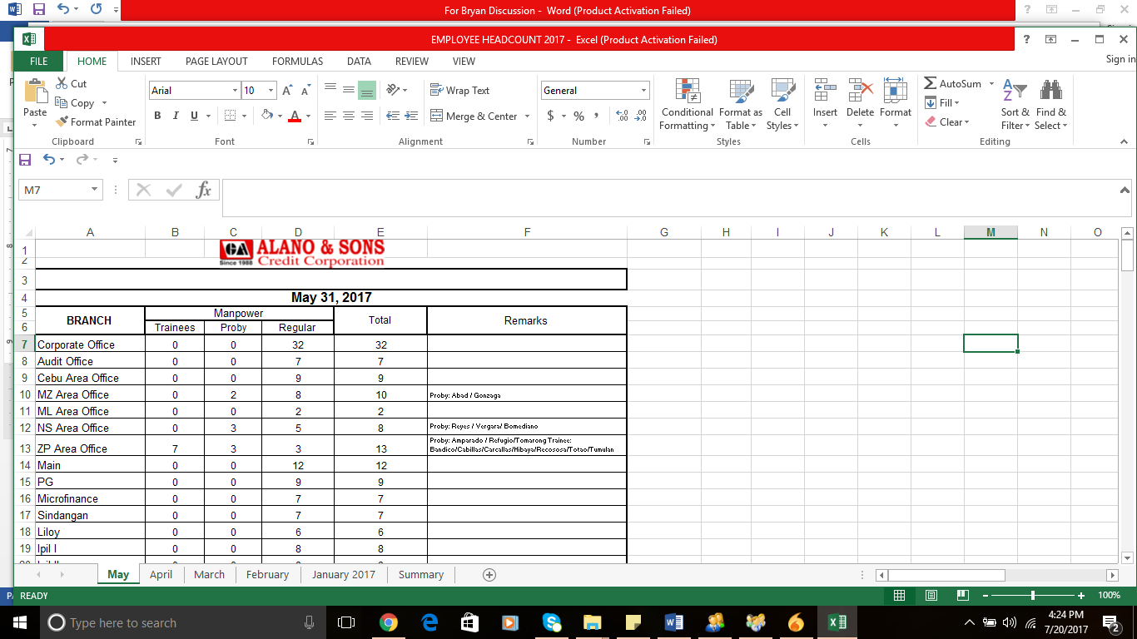

Employee headcount with profile ( in pie chart- Male, Female )

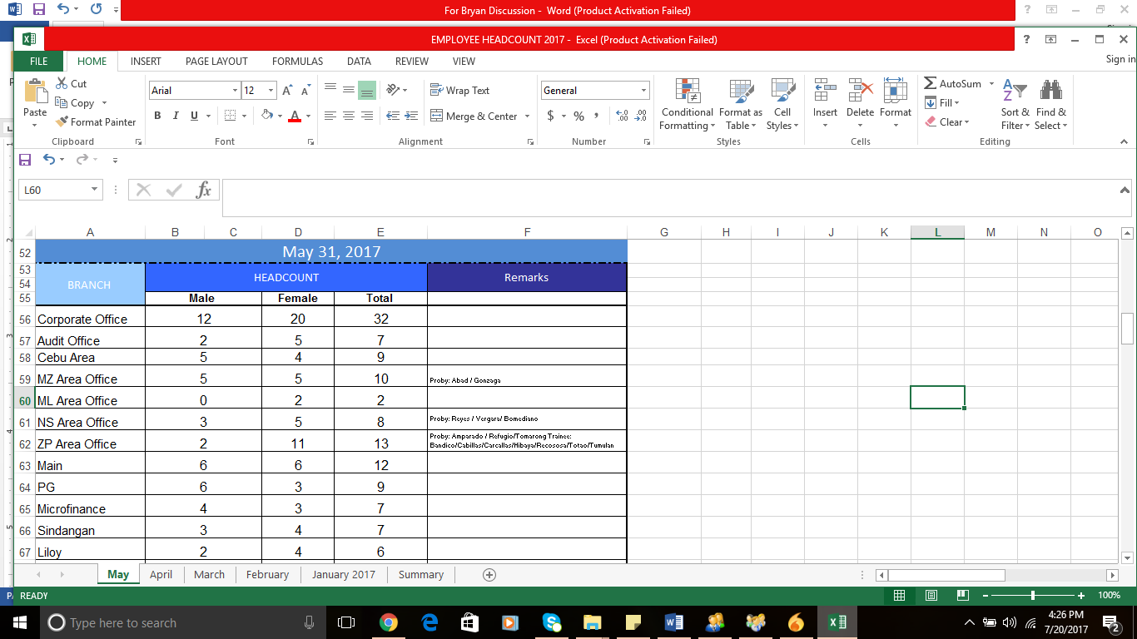

Employee Masterlist

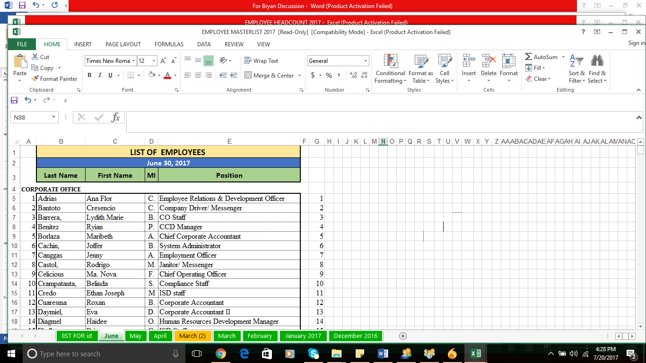

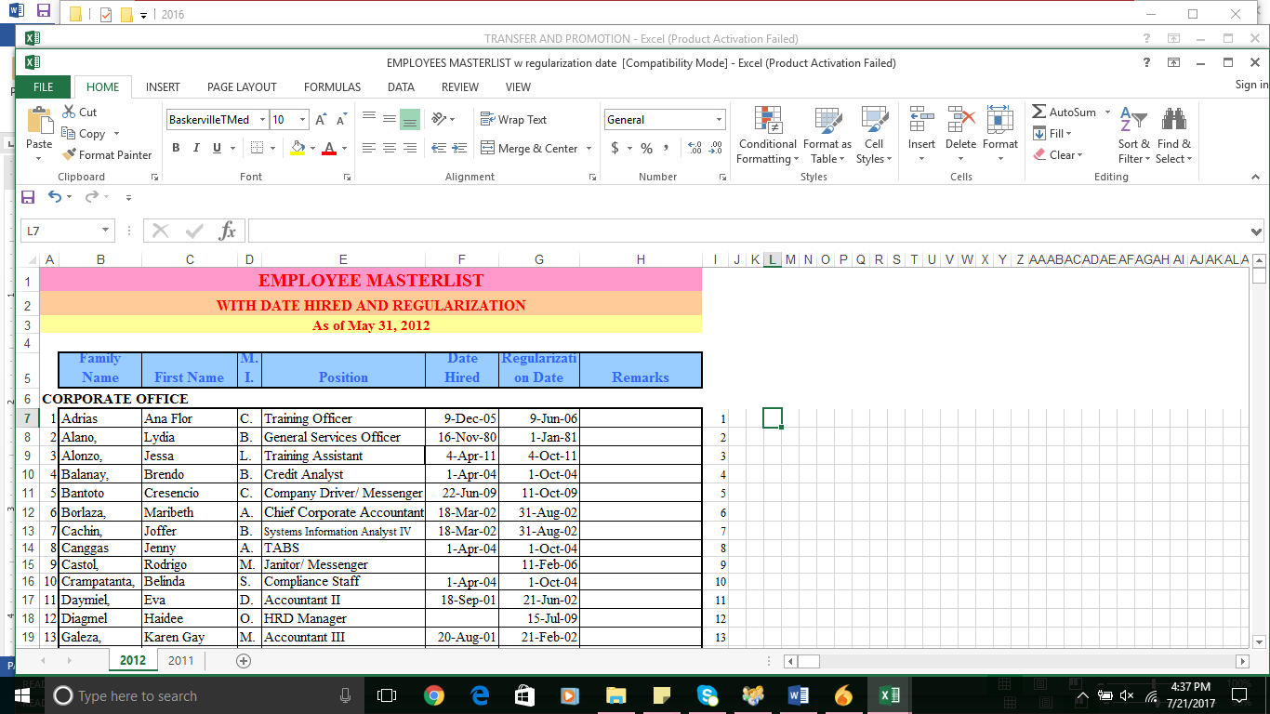

*Note: Masterlist can also be generated with other needed details- birthday; course, address, civils status, etc*

* Loyalty Awards – can be generated based on length of service ( 5 years, 10, 15 and 20th… )

* Cash Gift Recipients – based on employees regaularized

Policy: For 1st year of service =1000 , every year of service= 500 but maximum of 5000

Newly appointed OIC-1,000

Acting BMs not yet confirmed-1,500

Confirmed BMs-3,000

Acting AM/ Acting Area Head/Area Head=4000

Area Managers/ Dept Heads=4000

COO=5000

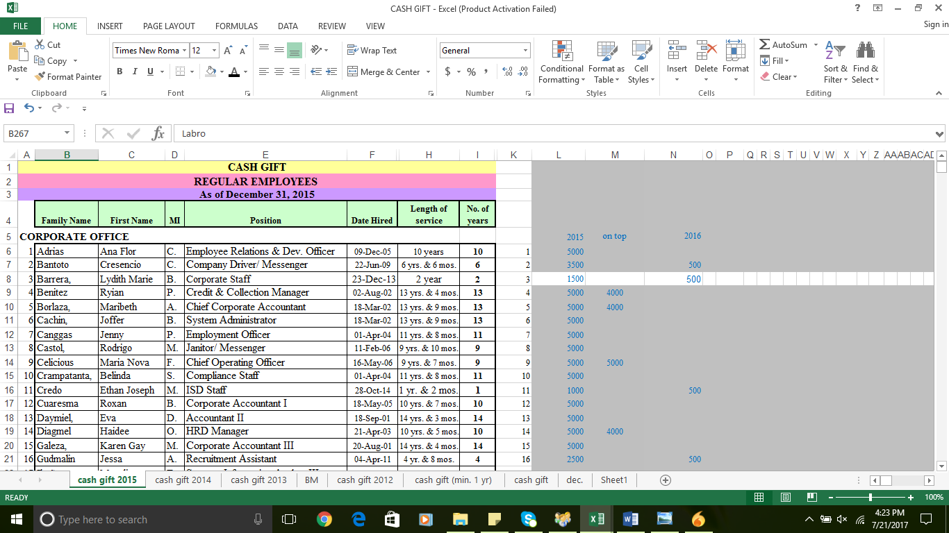

* 14th month pay recipients – based on length of service from date of regularization/ performance appraisal result/
* Uniform Allowance

Commission from troubled Accounts

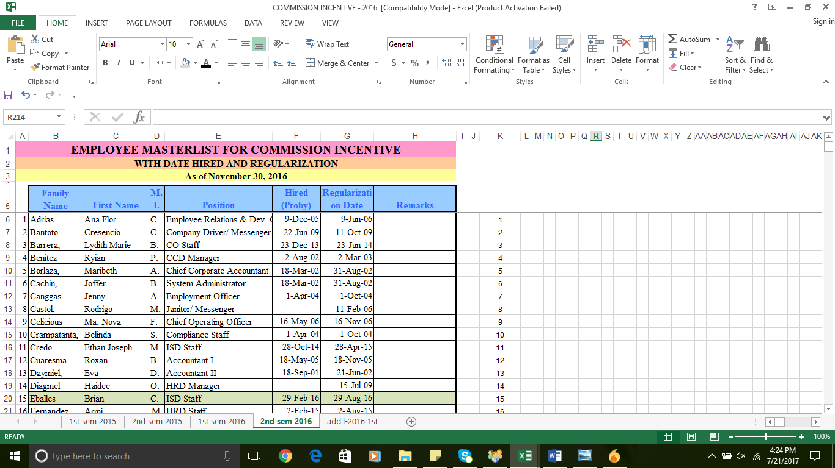

* Jackets Recipients
* Employees” Birthdays ( List of employees with birthdays every month = name of employee/ birthday/ branch

**ATTENDANCE REPORT**

* **Perfect Attendance** – Awardees for a given period ( perfect logs except for bday leave, BTF and overrides due to system error etc )
* **PB and TAMI reports** -List of Employees at a given period of time ( revious period – with their previous branch of assignment and current assignment )

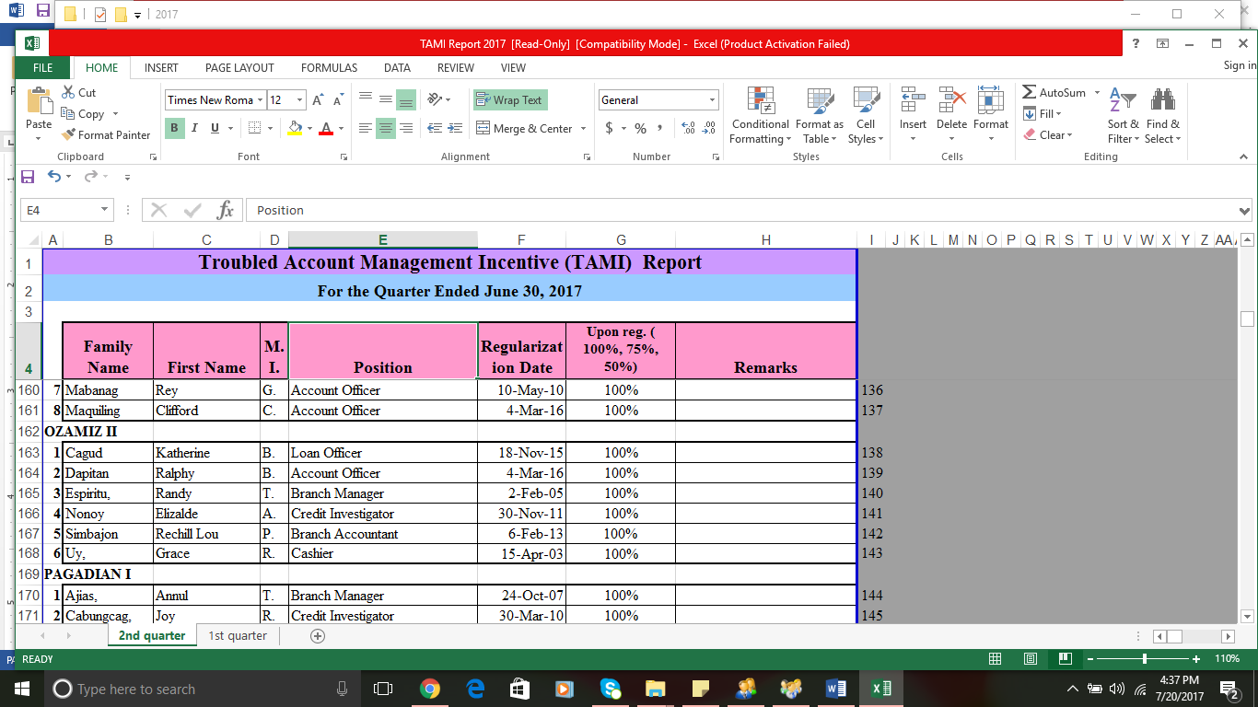

Qualifications :



* LPPP Attendance

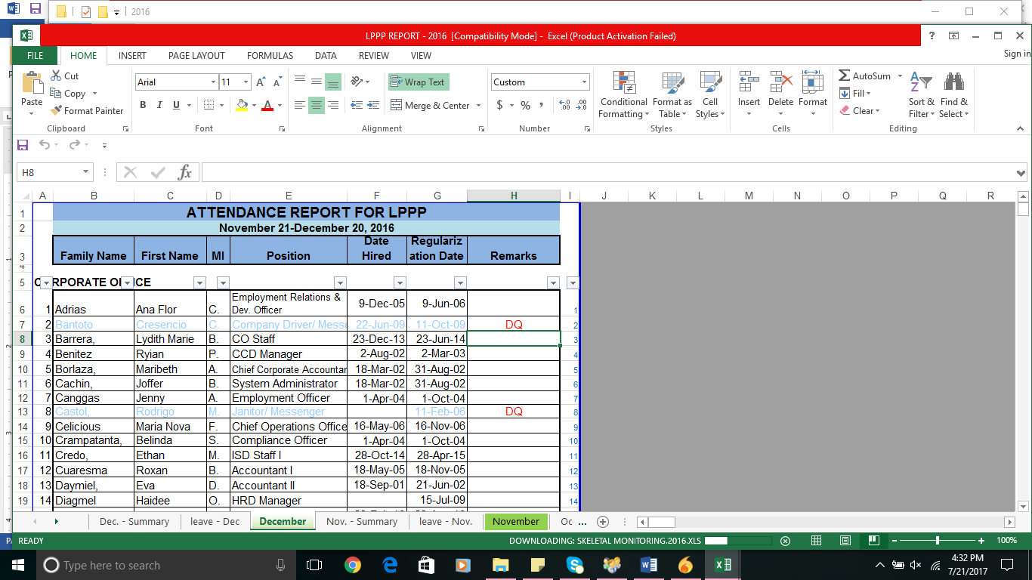

**Benefits availment** 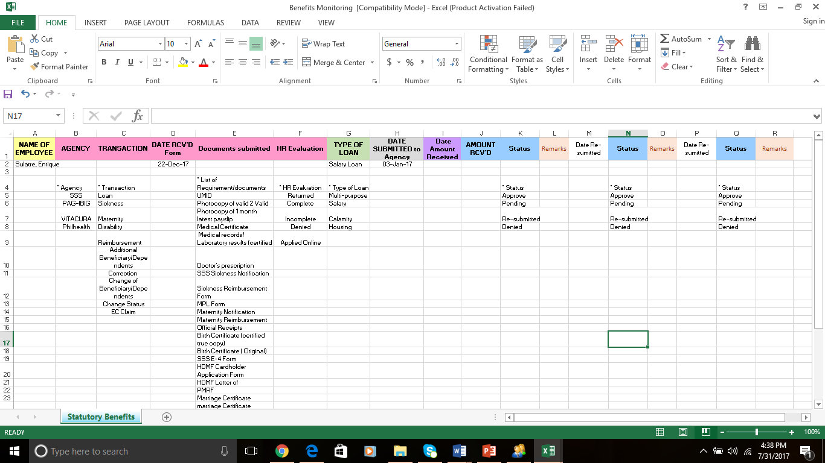

**COMPANY BENEFITS AVAILMENT**

* VACATION LEAVE AVAILMENTS PER BRANCH FOR THE YEAR
* SL AVAILMENTS PER BRANCH
* COMMON REASONS FOR SL
* SKELETAL MONITORING
  + List of Saturdays reported
  + Print-out of the monthly skeletal Schedule
  + Exchanges—and reasons can be viewd/ printed

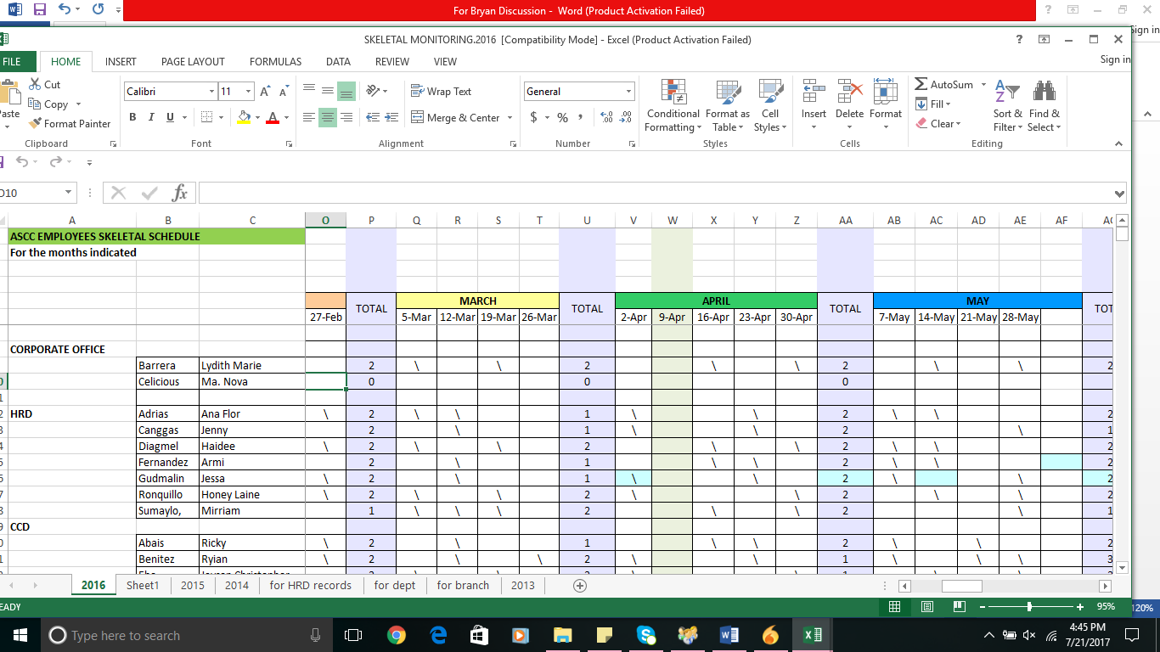

**This report can arranged per branch or alphabetical order as of a given period / month**

* VITA CURA –BENEFICIARY/ DEPENDENTS;
* VITA CURA AVAILMENT RECORDS, PREMIUS AND COMMON ILLNESS ( IN GRAPH )

**PAYROLL / BENEFITS**

* SSS employee and ER contribution per employee
* PB received per employee – every quarter
* TAMI – received by every employee per quarter
* PROMOTION AND TRANSFER- report for allowances purpose

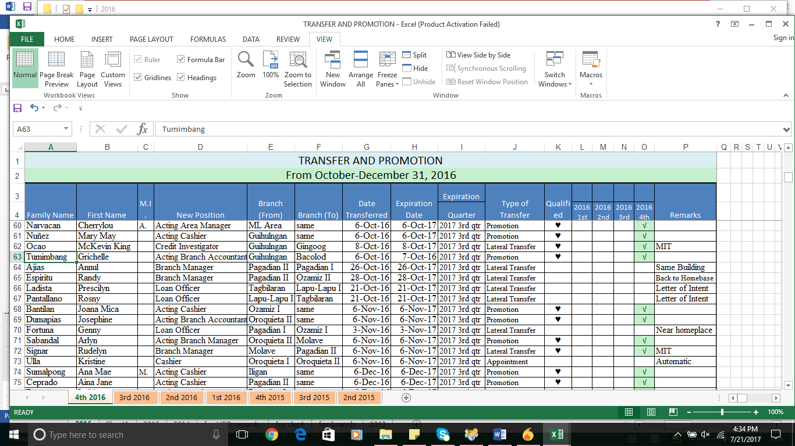

Note: if possible we can encode the conditions in PAF

( with Promotion and Transfer Allowance; and reasons why yes and no )

* LEAVE

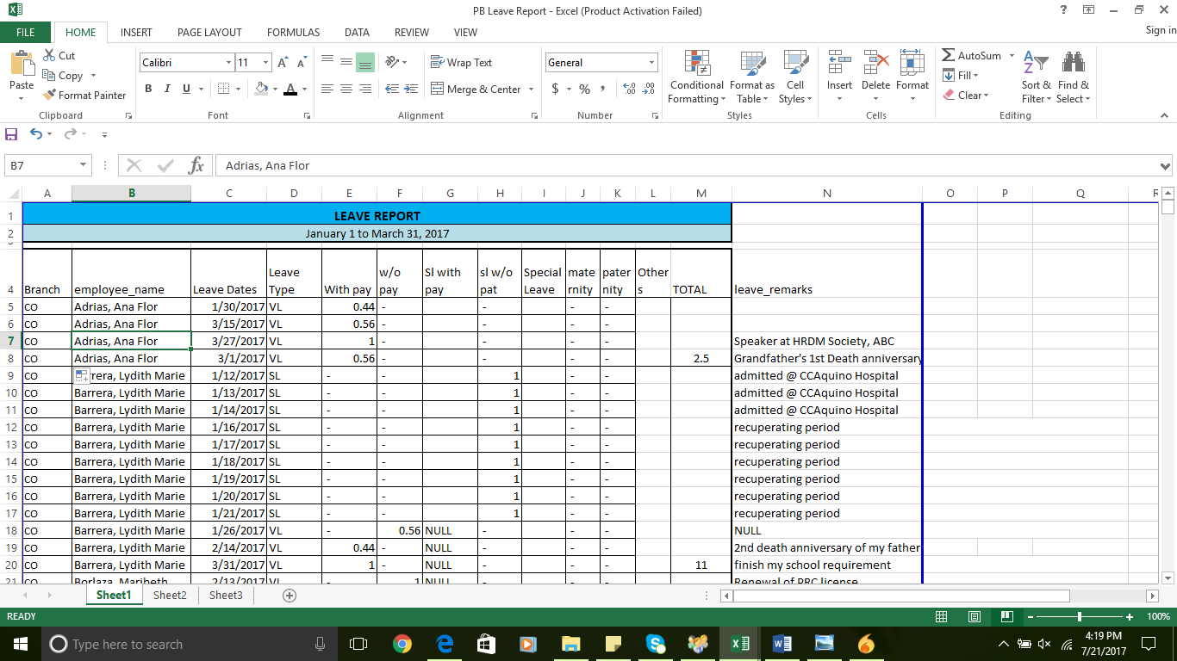

* **Can also generate a list without details of leave—but only total no. of leaves and business trip**

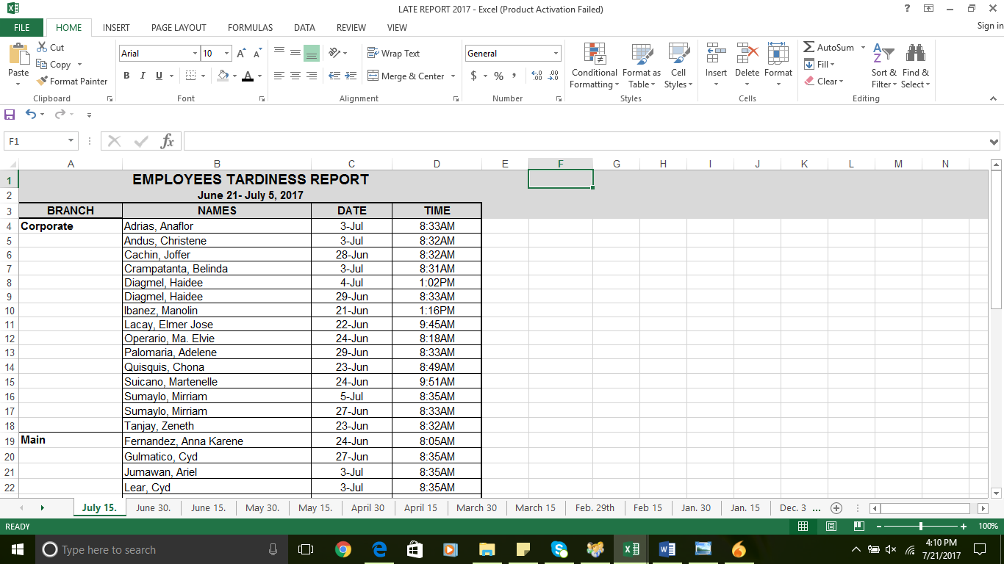

TO GENERATE LATE- AT LEAST ONE MINUTE

TO GENERATE ALSO- NO. OF TARDINESS PER EMPLOYEE PER PERIOD

* UNDERTIME REPORTS
* AWOL REPORT

Period Covered/ Name of Employee / Date of Absence without Leave

* INCOMPLETE ENTRIES REPORT

Period Covered / Name of Employees /branch/ Date/ Log in & out Details – can be generated month for a given period ( from- to)

**( to be referred to Ms. Georgee if still needed**

**)** 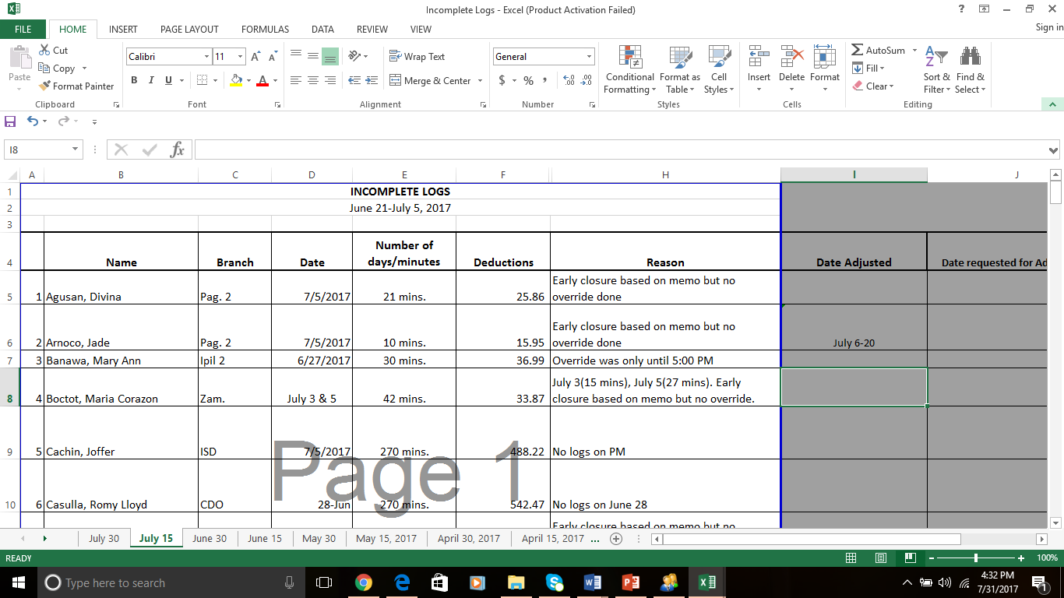

* ADJUSTMENT REPORT

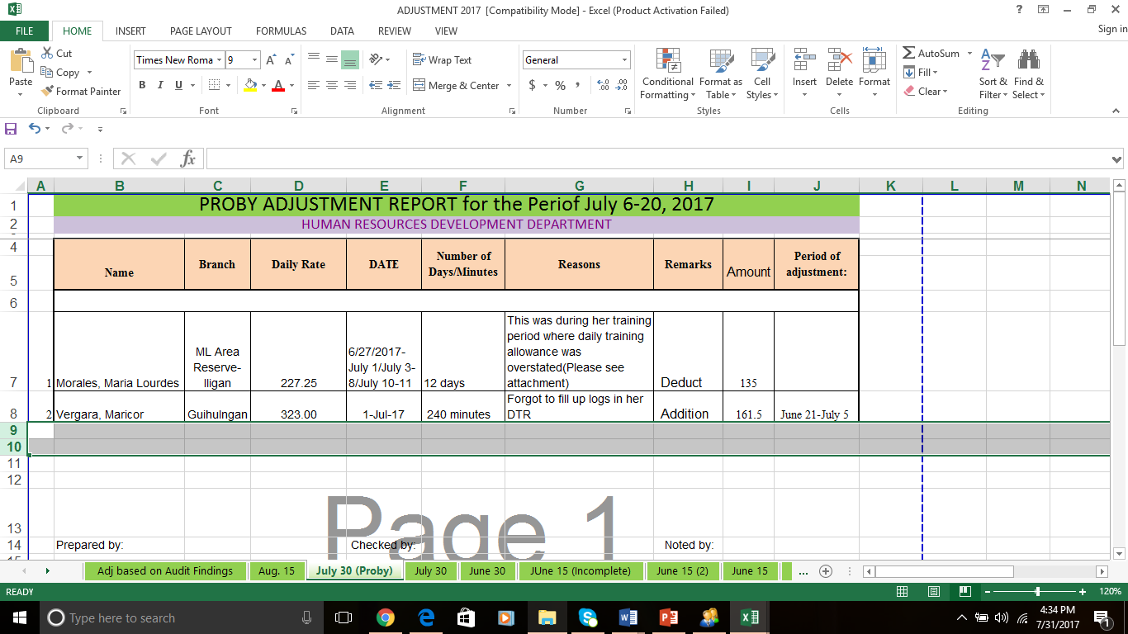

* CO ALLOWANCE REPORT

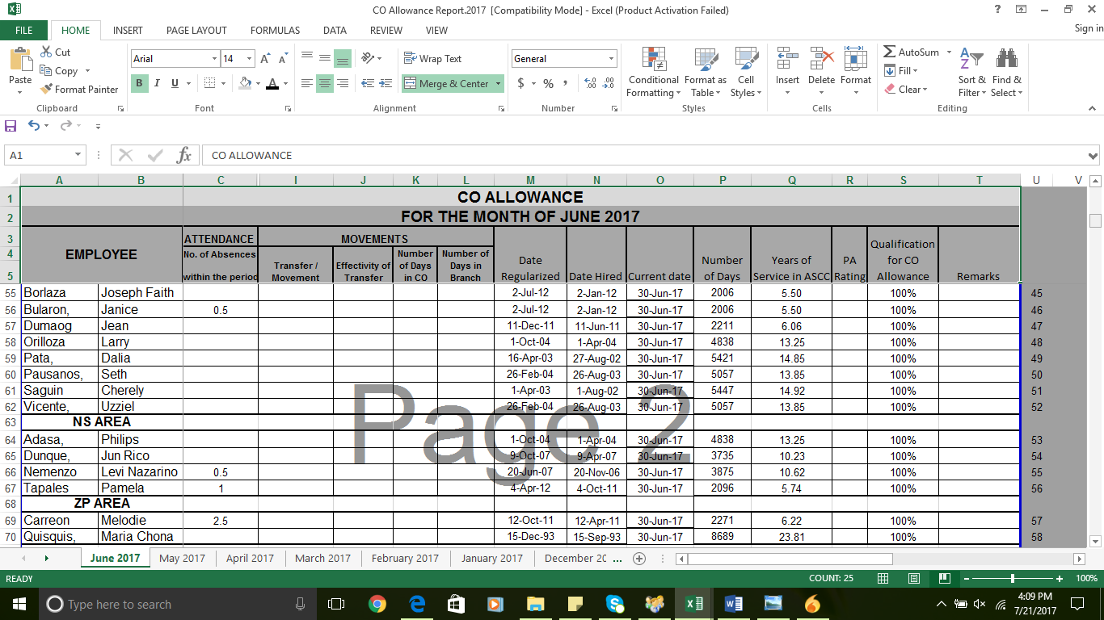

If possible the report will automatically determine qualification of employee based on length of service ( 50% and 100% )

* EMPLOYEES WITH ALLOWANCES AND THE AMOUNT ( LODGING, COLA, RELOCATION, RERPRESNTATION, HOME VISITS ETC )

**RESIGNATIONS**

1. **List of Resignees**

Name of Employee /Branch / Position / Date Effective /Last Working Day/Date Hired / Length of Service/ Reason / Details

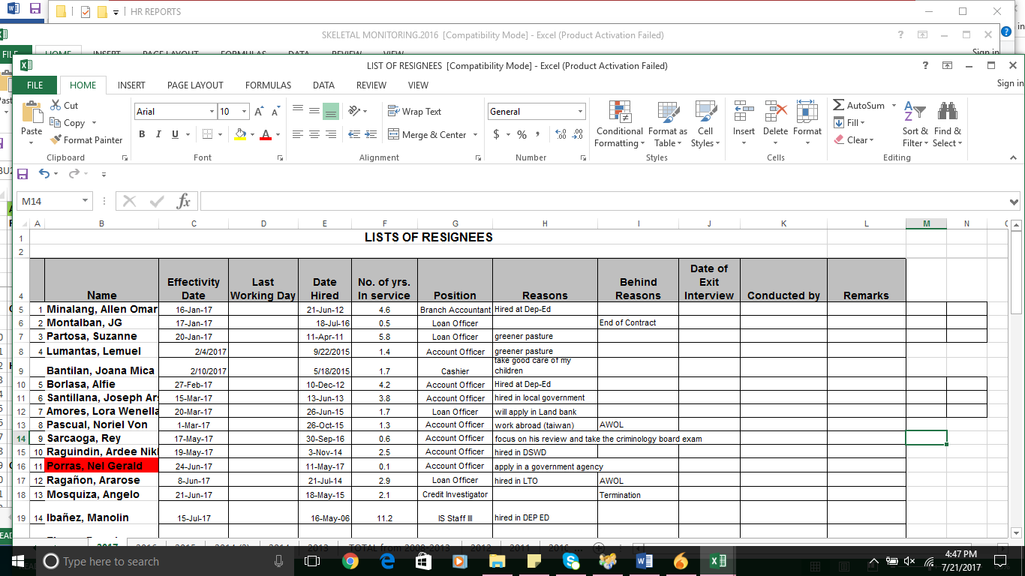

Note: We will just provide choices for reasons for resignation.

1. Another report can be generate as to **resignees for a certain period with reasons** ( presented in pie chart ) per position
2. Turn-over Rate generation for a given period ( resignees / average headcount x 100 ( average headcount = headcount beginning + headcount ending / 2 )
3. List of Retirees/ Dismembered/ Disabled ( Name/ Date Retired/ Separation Benefit )
4. List of Terminated Employees

Name / Cause ( Authorized / Just ) / Details or Violation / Termination Date

5. ) Reason Area-Must have generic reasons(Ex. Transfer to government, work abroad, others, please specify)